Gwybodaeth Thema i Rieni CA2 (Tymor yr Hydref) –
Theme information for KS2 Parents (Autumn Term)
Ysglyfaethwyr

Llythrennedd: Llythyr ffurfiol, e-bost, dwyn i gof, disgrifiad.
Literacy: Formal letter, e-mail, recount, description.

Rhifedd: Mesuriadau, datrys problemau, data, tymheredd, arian.
Numeracy: Measurements, problem solving, data, temperature, money.

T.G.Ch (digidol): Hwb, taenlen, basdata, ymchwilio ar-lein.
I.C.T (digital): Hwb, spreadsheet, database, online research.

Gwyddoniaeth: Sut mae fy nghorff yn gweithio? / Byw yn Iach.
Science: How does my body work? / Healthy Living.

Dyniaethau: Peryglon byd natur, anifeiliaid, newid o fewn byd natur.
Humanities : Wildlife dangers, animals, change in wildlife over time.

Ymarfer Corff: Dydd Llun (Dosbarth Miss Evans Blwyddyn 3, Dosbarth Miss James Blwyddyn 5 a 6)
Dydd Mawrth (Dosbarth Miss Edwards, Blwyddyn 4 a 5)
Physical Education: Monday (Miss Evans’ Year 3 Class, Miss James’ Years 5 and 6 Class)
Tuesday (Miss Edwards’ Years 4 and 5 class)

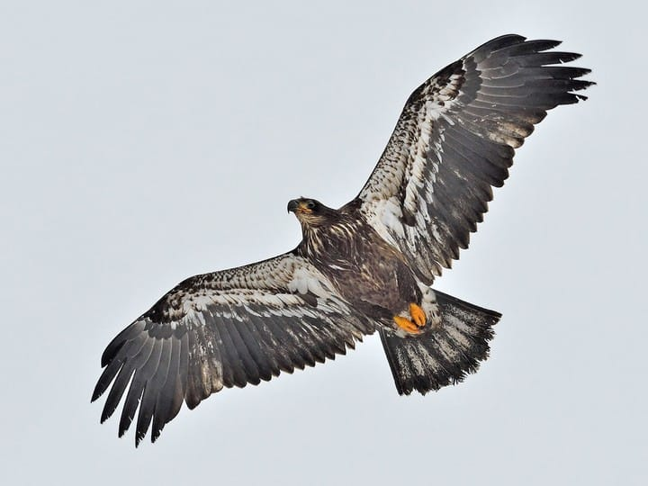
Addysg Grefyddol: Ffordd o fyw.
Religious Education: Lifestyle

Nofio: Blwyddyn 5 a 6.
Swimming: Years 5 and 6.

